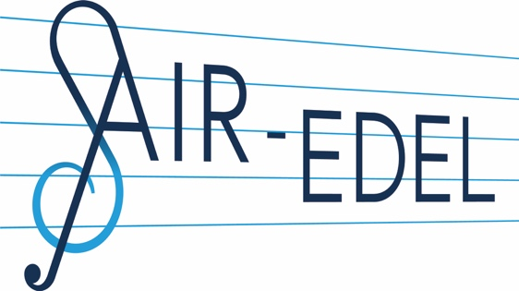
Ciara Elwis – Music Supervisor

Credit highlights:
After Life S2 (2020)
Sex Education S2 (2020)
This Way Up (2019)
Derry Girls (2018)

Ciara is a music supervisor who works across both creative research and source music clearance. She joined the Air-Edel team in 2015 and was quickly inducted into the world of sync, assisting on projects such as Channel 4/Netflix's doo-wop heavy ‘The End of the F***ing World’ and the John Hughes-inspired ‘Sex Education’, both of which have enjoyed considerable praise for their use of music, with numerous tracks being featured on The Hollywood Reporter’s Billboard Top TV Chart.

With credits on over 150 episodes of television and numerous films, Ciara enjoys an excellent working relationship with an extensive roster of labels, publishers and managers as well as possessing finely tuned(!) research skills. In 2017, she music supervised Channel 4's 90s’ banger-centric 'Derry Girls', and the following year, the Simon Pegg exec-produced comedy horror ‘Slaughterhouse Rulez’ for Sony Pictures.

More recently, Ciara has worked on Ricky Gervais’s hugely successful series ‘After Life’, as well as a docu-series with Charli XCX called ‘I’m with the band: Nasty Cherry’ (produced by the Academy Award-winning production company Grain Media for Netflix), and the script-writing debut from Irish comedian Aisling Bea ‘This Way Up’, also starring Sharon Hogan and produced by Merman Productions.

Ciara is comfortable working at all stages of a production, from providing advice at script stages to pre-records and on-set supervision, to post-production copyright clearances. She is currently working on 'I may destroy you', written by and starring Michaela Coel for the BBC and HBO, Joanna Hogg's The Souvenir part 2 and 'The Duchess', written by and starring Katherine Ryan.

FILM AND TELEVISION CREDITS & IMDb LINK
Music Supervision
After Life S2
Derek Productions / Netflix
2020
Almost Never S2
SaltBeef TV / CBBC
2019
I’m with the band: Nasty Cherry
Grain Media / Netflix
2019
This Way Up
Merman Productions / Channel 4
2019
Ibiza: The Silent Movie
Directed by Julian Temple
Essential Arts
2019
The Souvenir (Air-Edel as music consultant)
Directed by Joanna Hogg
BBC Films
2019
Almost Never S1
SaltBeef TV / CBBC
2019
Derry Girls
Hattrick Productions / Channel 4
2018
Slaughterhouse Rulez
Directed by Crispian Mills
Catalyst Global Media / Sony Pictures
2018

Rosemary & Basil
Directed by Max Gill
Heretic Productions / Ugly Duckling Films
2018

Await Further Instructions (score supervision)
Directed by Johnny Kevorkian
2018

Little Pyongyang
Directed by Roxy Rezvany
Guardian Films
2018

Barbados (music consultant)
Directed by Misha Manson-Smith
Funny or Die
2017

Assistant Music Supervision
Sex Education S2
Eleven / Netflix
2020
After Life
Derek Productions / Netflix
2019
Traitors
Twenty Twenty Television / Channel 4
2019
Sex Education S1
Eleven Film / Netflix
2019
The Little Drummer Girl
The Ink Factory / BBC
2018
Grandpa’s Great Escape
King Bert / BBC
2018
Lovesick S3 Clerkenwell Films / Netflix
2018
Dirk Gently’s Holistic Detective Agency
BBC America / Netflix
2017
The End of the F***ing World
Clerkenwell Films / Channel 4 & Netflix
2017
Cold Feet
Granada Television / ITV
2017
Loaded
Hillbilly Films / Channel 4
2017
Gap Year
Eleven Film / E4
2017
The Party
Directed by Sally Potter
Adventure Pictures
2017
Habaneros
Directed by Julian Temple
Essential Arts
2017
My name is Lenny
Directed by Ron Scalpello
Salon Pictures
2017
Witness for the Prosecution
Mammoth Screen / BBC
2016

Lovesick S2
Clerkenwell Films / Netflix
2016

The Aliens
Clerkenwell Films / E4
2016

